District Updates/Activity as per 17th June, 2021
The Uganda Women Entrepreneurship Programme (UWEP) Monitoring, Evaluation and Recovery Exercise for Asuret Sub County, Soroti district.
The activity was carried out today on 17th June, 2021 by the office of the Focal Point Person UWEP, and that of the District Community Development Officer-DCDO.
A total of 14 registered groups of Women that have already benefited from this program, with most of the group benefiting in the financial year 2018/2019, 2019/2020 and 2020/2021.
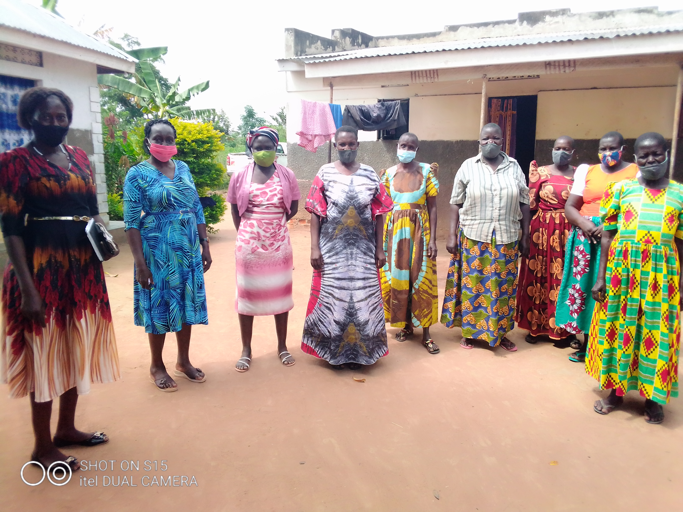
Adalla women produce and selling group posing for a group photo with Soroti team.
The groups includes; Gwetom Women Grinding Mill, Obilai Ikukwai Women’s Produce buying and selling, Adacar Angor Kuju Women Cattle Trade, Otatai Central Women Cattle Trade, Apwot women produce buying and selling group, Opelepe Women Cattle Trade, Okweny Emorokinos Women produce buying and selling, Orajai /Obutet Women producing and selling, Ateng women produce buying and selling , Olelebu women produce and selling, Otaaba women produce and selling, Okalis women tailoring, Fashion and Designe, Adalla Women produce buying and selling and Okidoi women value addition.

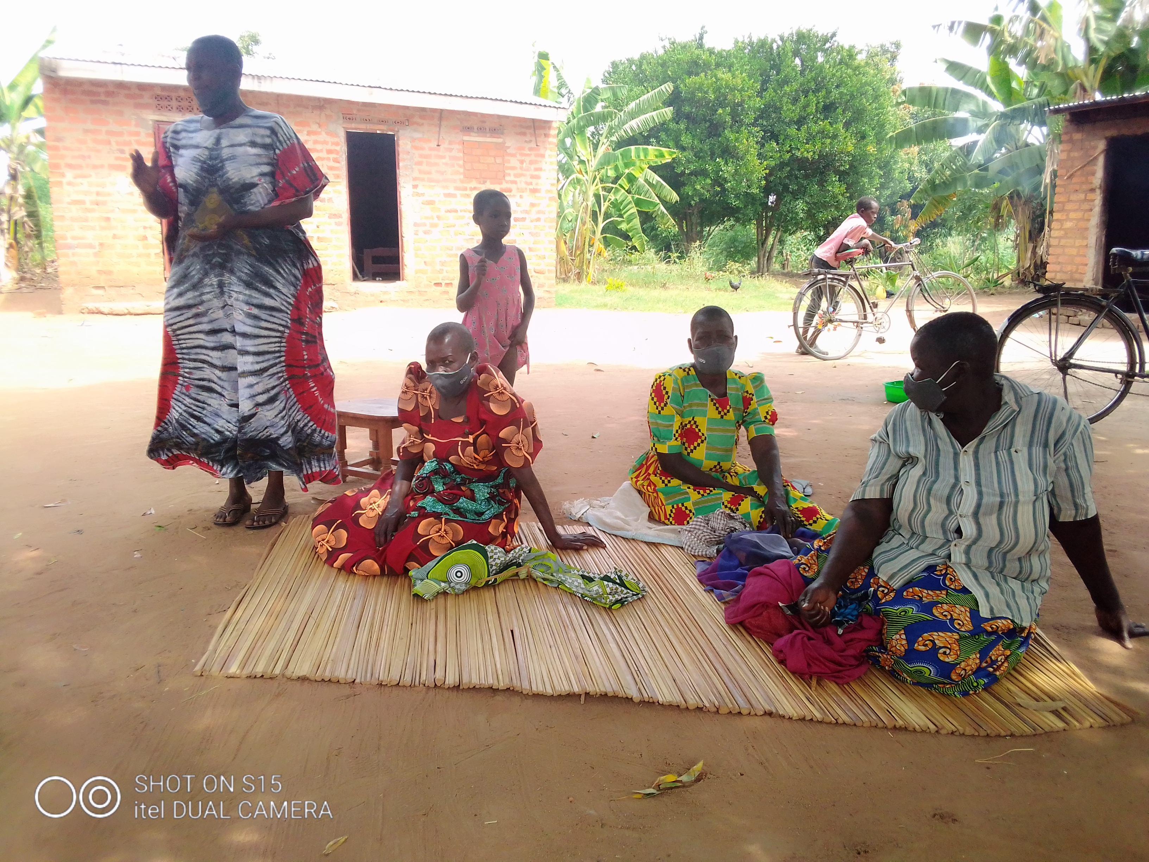
Adalla women produce buying and selling, sharing with monitoring team.
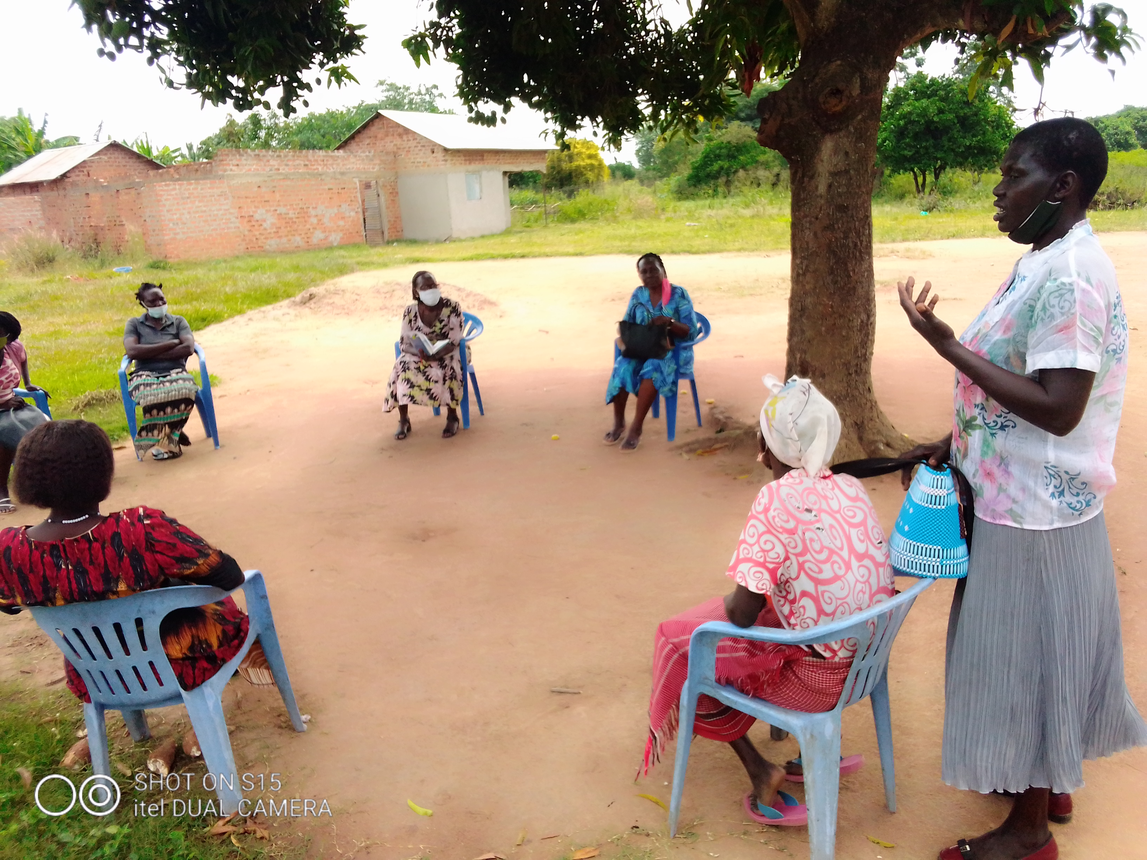
Otaaba women produce buying and selling, sharing with monitoring team.

The Uganda Women Entrepreneurship Programme (UWEP) is an initiative of the Government of Uganda that is aimed at improving access to financial services by women and equipping them with skills for enterprise growth, value addition and marketing of their products and services. UWEP is intended to empower Ugandan women for economic development.
Daisy Ayigi, the Focal Point Person-FPP notes the UWEP which was implemented in Soroti during the financial year 2016/17 has greatly improved the economic and income levels of women.

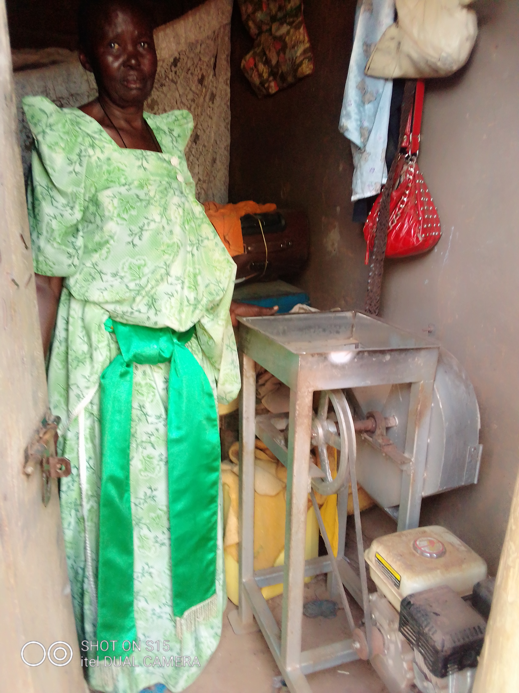
Standing is Grace Imala , Otatai Central womens group bought the Cassava slicing machine

Ayigi says the primary target beneficiaries of the program are women within the age bracket of 18-79 years with the eligibility criteria of such as the unemployed women. Vulnerable groups e.g. single young mothers, widows and gender-based violence survivors, Women with disabilities , Women living with HIV / AIDS, Women heading households, Women slum dwellers, Women living in hard to reach areas such as on island and ethnic minorities.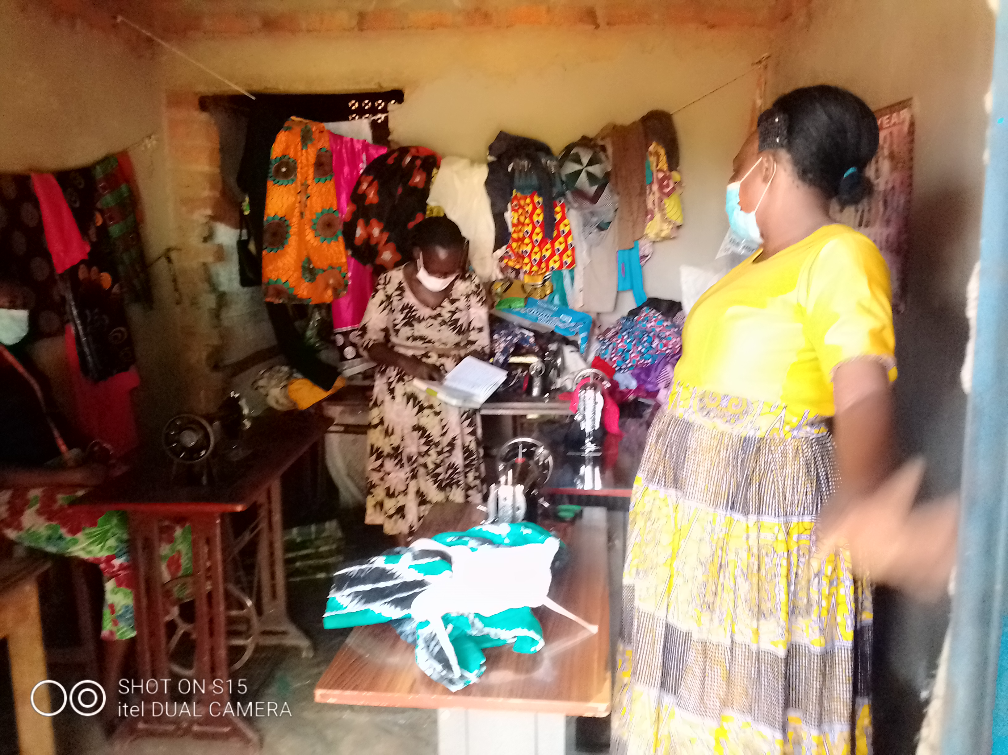

Programme Goal
The overall goal of the Programme is to empower Ugandan women to improve their income levels and their contribution to economic development.

Specific Objectives;
- To strengthen the capacity of women for entrepreneurship development

- To provide affordable credit and support access to other financial services to enable women establish and grow their business enterprises

- To facilitate women’s access to markets for their products and services

- To promote access to appropriate technologies for production and value addition

- To strengthen Programme management and coordination.

However during the monitoring, evaluation and recovery exercise, women’s independency financially has improved, the social statutes and wellbeing has greatly improved as tested by majority them.

“Life has improved to same extent, we are able to feed, paying schools fees and finanacil stand at individual level has improved,” noted by Phoebe Awalo, the chairperson Adalla Women produce and selling group.
Others explains they no longer depend so much on their husbands to provide home needs.
But, it was observed that there was low recovery by most of the women groups.
When asked by the DCDO, Margaret Emuria Acaya, the women said that most of their projects were affected by the Covid-19 lockdown, explaining a number of them who ventured into produce buying and selling could not carry out business as stipulated.
This affected their recovery, but promised they will abide and start the process of the re-paying.

The monitoring, evaluation and recovery exercise continues on Friday 18th June, 2021 in the sub county of Katine.

From the Communications Office.
I thank you.
Abraham Ekwaru.
Copied to all media houses.

